Thursday Bidding Tips 9 Board 14 played on 21/6/2018 Horowhenua Pairs
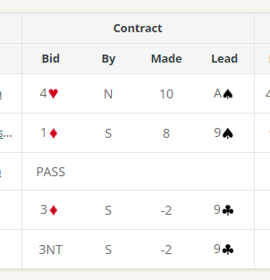
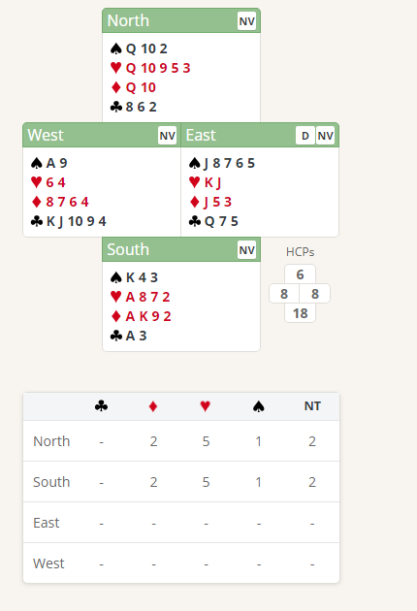

Suggested Bidding 1
N | E Dealer | S | W
 | Pass | 1D | Pass
1H | Pass | 4H | Pass
Pass | Pass

- Souths s bid of 1 Diamond shows 12-19 points and at Least 4 Diamonds.
- Norths reply of 1 Heart shows 6+ points and 4 Hearts
- South with 4 Hearts and 18 Points Jumps to 4 hearts (game raise with 18-19 points). South should not rebid Diamonds as they only have 4
- North with 6 points passes

Suggested Lead from East 6 Spades (4th Of longest Suit)

Further notes about Responder’s New Suit Bids
http://www.nzbridge.co.nz/user/inline/2341/NZB%20Beginner%2004A%20-%20Student%20Notes.pdf

